Urban Development and Vegetation Change in Hangzhou, China, 1995 to 2025: A Landsat-Based Analysis

Introduction
Hangzhou is a cultural and economic center in eastern China that has undergone rapid built-up expansion. It has also implemented urban green space programs. Both processes leave a spectral signature in satellite imagery. This project therefore examines how vegetation cover changed in Hangzhou between 1995 and 2025, and what the spatial pattern of that change reveals about the form the expansion took.
The project has two parts, and draws on three summer Landsat scenes from 1995, 2010 and 2025. The first measures the change: a vegetation density classification for each date, the area that changed between them, and an accuracy assessment of that classification.
The second examines whether the three images can be compared at all. They match closely on paper, but this project goes a step further and checks their radiometry, to confirm that measured changes reflect real differences on the ground rather than differences between the scenes themselves.
Together the two parts answer one question: what changed, and how much of that change can be trusted. A date that fails the checks is still classified and mapped, but is left out of the measurements, since a scene that differs from the others can manufacture change that never happened. The analysis remains descriptive throughout and does not test what caused the pattern.
Background
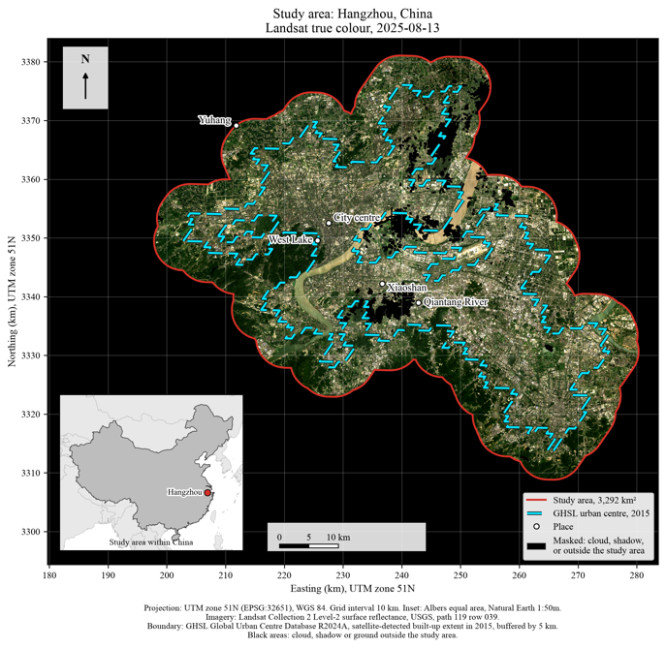
Hangzhou lies about 180 km southwest of Shanghai in the Yangtze River Delta (Yu et al., 2017), and its recent growth has pushed outward from the historic core around West Lake across the Qiantang River. Chen and He (2022) document this on the south bank, where urban land in Xiaoshan District rose from 91.98 km² to 294.82 km² between 1985 and 2020, growth that "converted a substantial quantity of basic agricultural land into urban construction land." Because the expansion consumed cultivated land rather than forest, Hangzhou is a useful case for separating built-up growth from agricultural change, which a vegetation index alone cannot distinguish.
Alongside that growth is an unusually well-documented greening effort. Hangzhou was designated an "ecological civilization capital" at the 2016 G20 Summit, and in May 2025 adopted regulations that include a citywide "five-minute access to greenery" park plan and a target of 25 million square meters of new green space by 2030 (ehangzhou.gov.cn, 2025a; 2025b). The 2025 regulations postdate the imagery used here, so they are cited as evidence of a sustained policy direction rather than as a cause of anything observed.
The most directly relevant prior work is Yu et al. (2017), who mapped Hangzhou's urban green space from Landsat imagery for 1990, 2002 and 2013, using path 119 and row 39, the same path and row used here. Their conclusion has two sides, and sets up the question this project asks. They report that "Hangzhou has experienced a significant loss of urban greenness," producing a more fragmented vegetation landscape, while also finding "a remarkable amelioration of urban greenness" in the city core between 2002 and 2013. Loss and gain occurred together rather than in sequence, and in different parts of the city.
Extending that record to 2025 adds twelve years and covers the period in which the greening programs above were put in place. Classifying each date also allows the two directions of change to be reported separately, which a citywide index mean cannot do.

Data
The analysis uses three Landsat Collection 2 Level-2 scenes, all Tier 1 and all from WRS-2 path 119, row 039, accessed through the Microsoft Planetary Computer STAC API.
Year | Scene ID | Date | Sensor | Usable coverage
1995 | LT05_L2SP_119039_19950803_02_T1 | 3 Aug 1995 | Landsat 5 TM | 98.69%
2010 | LT05_L2SP_119039_20100812_02_T1 | 12 Aug 2010 | Landsat 5 TM | 98.20%
2025 | LC09_L2SP_119039_20250813_02_T1 | 13 Aug 2025 | Landsat 9 OLI | 95.34%
The three dates fall within ten calendar days of each other, which keeps crop stage and solar geometry broadly comparable. An earlier attempt using November and December scenes was abandoned as winter crop conditions differed widely between dates, and QA_PIXEL flagged 6.46% of the 1995 winter scene as snow or ice, including parts of the Qiantang River.
Six optical bands are used from each scene: blue, green, red, near infrared, and both shortwave infrared bands. Two quality bands are also retrieved: QA_PIXEL, which carries cloud, shadow, snow and water flags as individual bits, and QA_RADSAT, which flags radiometric saturation.
The study-area boundary comes from the GHSL Global Urban Centre Database R2024A. The Hangzhou urban center polygon (ID 11311) is buffered by 5 km to include the peri-urban fringe, covering 3,291.58 square kilometers. Because that boundary is derived from satellite-detected built-up extent in 2015 rather than from Hangzhou's administrative borders, greening statistics from official city sources describe a different area and serve as background for this project rather than as a benchmark.
No field data or high-resolution imagery is available for 1995, which constrains the accuracy assessment described below.
Proposed workflow

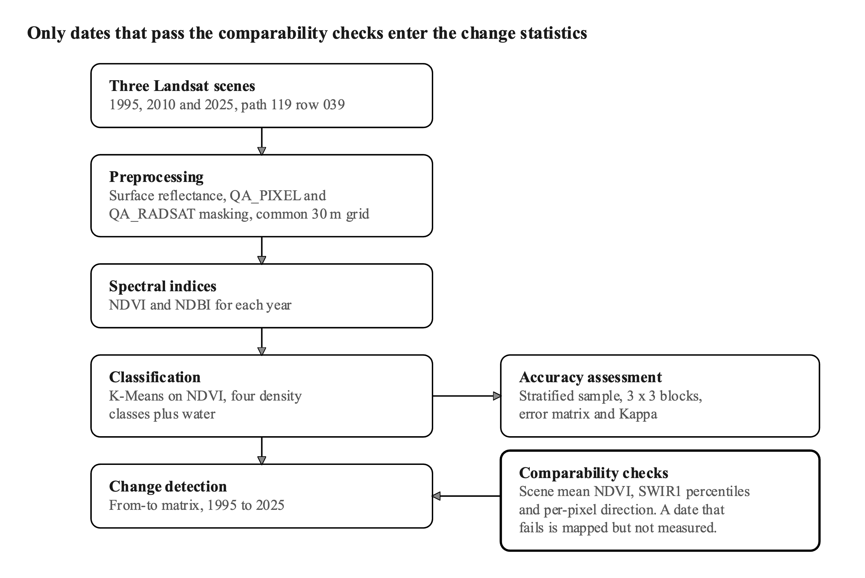
Preprocessing. Digital numbers are converted to surface reflectance (DN x 0.0000275 - 0.2), pixels flagged in QA_PIXEL or QA_RADSAT are removed, and water is kept because it becomes its own class. The scenes are then placed on a common 30 m grid in EPSG:32651 by nearest neighbor resampling, which copies pixel values without averaging them, and a mask of pixels usable in all three years keeps every comparison on the same ground.
Spectral indices. NDVI, (NIR - Red) / (NIR + Red), tracks green vegetation, and NDBI, (SWIR1 - NIR) / (SWIR1 + NIR), tracks built-up and bare surfaces. Differences are taken as the later year minus the earlier one, so a positive value means the index rose.
Classification. Unsupervised K-Means sorts each date into four vegetation density classes, fitted once on all three years pooled and on NDVI alone. Water forms a fifth class taken from the quality mask, because water and deep shadow can share a similar index value.
Comparability checks. The scenes are compared against each other before any change statistics are calculated, using the scene mean NDVI, the distribution of SWIR1 reflectance across percentiles, and the direction each pixel moves across the three dates. A date that proves not comparable is still classified and mapped, but is left out of the measurements.
Change detection. The class maps are compared pixel by pixel as a from-to matrix of transitions, so the dates need not be radiometrically identical, although errors in either classification carry into the result. A pixel counts as changed only if its NDVI also moved by at least 0.15, roughly three quarters of a class width.
Accuracy assessment. A stratified random sample is drawn with a fixed number of points per class, each covering a 3 x 3 block, with a minimum distance between points to limit spatial autocorrelation. Points are labelled by eye from false-color composites and tabulated as an error matrix giving overall accuracy, producer's and user's accuracy, and Kappa.
Software. Processing is scripted in Python with rasterio, numpy and scikit-learn. The workflow is reproducible in ENVI as a density slice on the NDVI thresholds, Change Detection Statistics, and the Confusion Matrix tool, while Python handles the two steps ENVI does not support directly, unpacking the QA_PIXEL bit flags and comparing statistics across scenes.
Two choices in the classification depart from the standard procedure. Fitting the clustering year by year puts the cluster boundaries in different places, so the classes could not be compared between dates. Clustering on all six reflectance bands was tested first, and it followed overall scene brightness rather than land cover, which is why NDVI alone is used. Because the classes come from NDVI alone, they measure vegetation density rather than land cover.
One limitation must be stated. No independent reference data exists for 1995, so the reference labels are read from the same imagery that was classified, which measures agreement between the classifier and the analyst rather than agreement with the ground. Yu et al. (2017) met the same constraint in the same study area and assessed accuracy only for their 2002 and 2013 dates "because a reference image for 1990 was unavailable."

References
Chen, Y.; He, Y. Urban Land Expansion Dynamics and Drivers in Peri-Urban Areas of China: A Case of Xiaoshan District, Hangzhou Metropolis (1985-2020). Land 2022, 11(9), 1495. doi:10.3390/land11091495
European Commission, Joint Research Centre. GHSL Global Urban Centre Database R2024A, version 1.2.
Hangzhou enacts green city law for eco-civilization model. ehangzhou.gov.cn, 4 August 2025. Link
Hangzhou passes nation's first local law on building an ecological civilization capital. ehangzhou.gov.cn, 27 May 2025. Link
Microsoft Planetary Computer. Landsat Collection 2 Level-2 STAC API. planetarycomputer.microsoft.com
U.S. Geological Survey. Landsat Collection 2 Level-2 Science Product Guide.
Yu, Z.; Wang, Y.; Deng, J.; Shen, Z.; Wang, K.; Zhu, J.; Gan, M. Dynamics of Hierarchical Urban Green Space Patches and Implications for Management Policy. Sensors 2017, 17(6), 1304. doi:10.3390/s17061304

QA_PIXEL records, for every pixel, a set of condition flags packed as individual bits, including fill, cloud, dilated cloud, cloud shadow, snow and water; these flags are produced by an automated algorithm rather than measured directly, so they are treated here as an input to be checked rather than as ground truth.

